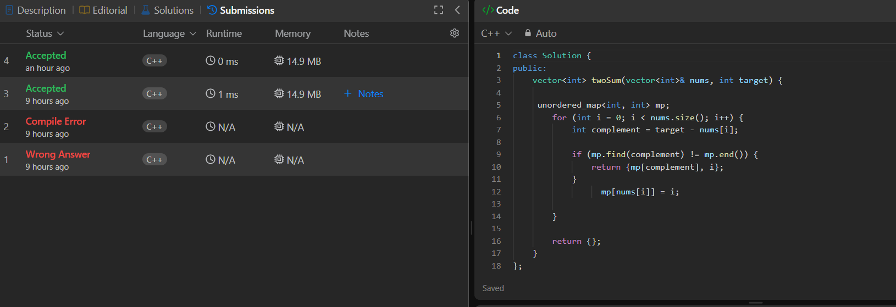
class Solution {
public:
vector<int> twoSum(vector<int>& nums, int target) {

unordered_map<int, int> mp;
for (int i = 0; i < nums.size(); i++) {
int complement = target - nums[i];

if (mp.find(complement) != mp.end()) {
return {mp[complement], i};
}
mp[nums[i]] = i;

}

return {};
}
};

